Bedroom Plan
The Centre has two floors of bedrooms. Both floors can be reached by the front or back stairs which is useful if you have mixed age groups or want to separate boys and girls etc.
First Floor Bedrooms and number of beds.

Birnock Water 8 Bell 4 Thomson 4 Gallow Hill 6 Bunk 2 En-suite 4
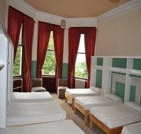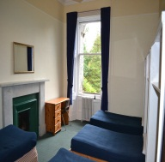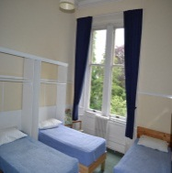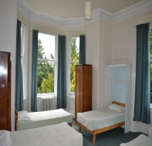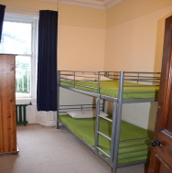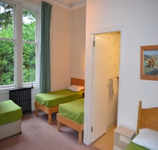
Middle landing
Sylvester 4 Bathroom & shower. Main bathroom :( 4 toilets & 5 sinks)
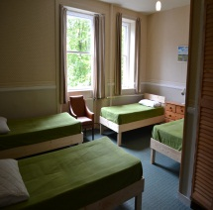
Top Floor
Grant 6 (3 bunks) Hagerty 8 Richardson 8 Rae 4 Lees 4 Poop deck 11
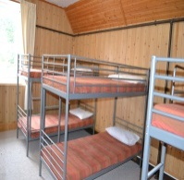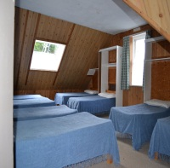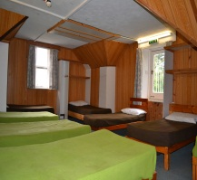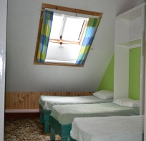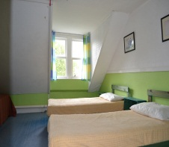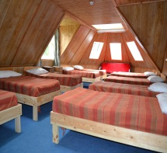
2 showers 3 washbasins & 2 toilets with wash basins next to Grant.

Ground Floor
There are 2 separate shower areas and 4 more toilets and 4 sinks. There is also a drying room. All the bedrooms have name plates to help you get organised before you arrive.
All the bedrooms are fire protected with smoke detectors and sounders.
Note: All bedrooms have standard 3’ single beds except in Rae and Haggerty which have 2’6’ size(more suited to youth.) Grant has 3 full size bunks.

